Flevin Maria Gulshan

SOLAR TRACKING MINI LIGHT SYSTEM USING GEMMA M0

ABSTRACT

This project presents the design and implementation of a Solar Tracking Mini Light System using the Adafruit Gemma M0 microcontroller, Light Dependent Resistors (LDRs), and an SG90 servo motor. The system automatically detects the direction of maximum light intensity and rotates toward the light source. The project demonstrates concepts of embedded systems, sensor interfacing, servo motor control, and automation. The system improves light collection efficiency and can be used in solar energy applications and smart lighting systems.

1. INTRODUCTION

Solar energy is one of the most important renewable energy sources in modern engineering. The efficiency of a solar panel or light-sensitive device increases when it directly faces the sun. Manual adjustment of solar panels is difficult and inefficient. Therefore, automatic solar tracking systems are used to improve efficiency.

This project develops a mini solar tracking system using simple electronic components. Two LDR sensors are used to detect light intensity from different directions. The Gemma M0 microcontroller compares the sensor values and controls a servo motor to rotate toward the brighter side.

The project is useful for learning:

* Embedded systems
* Sensor interfacing
* PWM motor control
* Renewable energy systems
* CircuitPython programming

2. OBJECTIVES

The objectives of this project are:

1. To design an automatic light tracking system.
2. To interface LDR sensors with the Gemma M0.
3. To control a servo motor using PWM signals.
4. To understand embedded system programming using CircuitPython.
5. To improve light collection efficiency using automatic tracking.

3. COMPONENTS USED

SI | Components | quantity | purpose
1 | Adafruit Gemma M0 | 1 | Main microcontroller
2 | SG90 Servo Motor | 1 | Rotates toward light
3 | LDR Sensors | 2 | Detect light intensity
4 | 10kΩ Resistors | 2 | Voltage divider circuit
5 | diode | 1 | Reverse current protection
6 | 3.7 v lithium battery | 2 | Power supply
7 | Connecting Wires | several | Circuit connection
8 | Solar panel | 1 | Demonstration output
4. THEORY

4.1 Light Dependent Resistor (LDR)

An LDR is a resistor whose resistance changes according to light intensity.

* High light → Low resistance
* Low light → High resistance

The LDR is connected in a voltage divider circuit so the Gemma M0 can measure changing voltage levels.

4.2 Servo Motor
The SG90 servo motor is a position-controlled motor that rotates according to PWM signals.
The servo operates between:
* 0°
* 90°
The motor shaft rotates depending on the pulse width generated by the Gemma M0.

4.3 PWM (Pulse Width Modulation)
PWM is used to control the servo motor position.
Servo specifications:
* Frequency = 50 Hz
* Pulse width = 1 ms to 2 ms
Different pulse widths produce different angles.

5. WORKING PRINCIPLE

1. Two LDR sensors continuously measure light intensity.
2. Gemma M0 reads analog values from both sensors.
3. The microcontroller compares the sensor values.
4. If the left LDR receives more light, the servo rotates left.
5. If the right LDR receives more light, the servo rotates right.
6. If both sensors receive equal light, the servo remains centered.
This allows the system to automatically track the brightest light source.
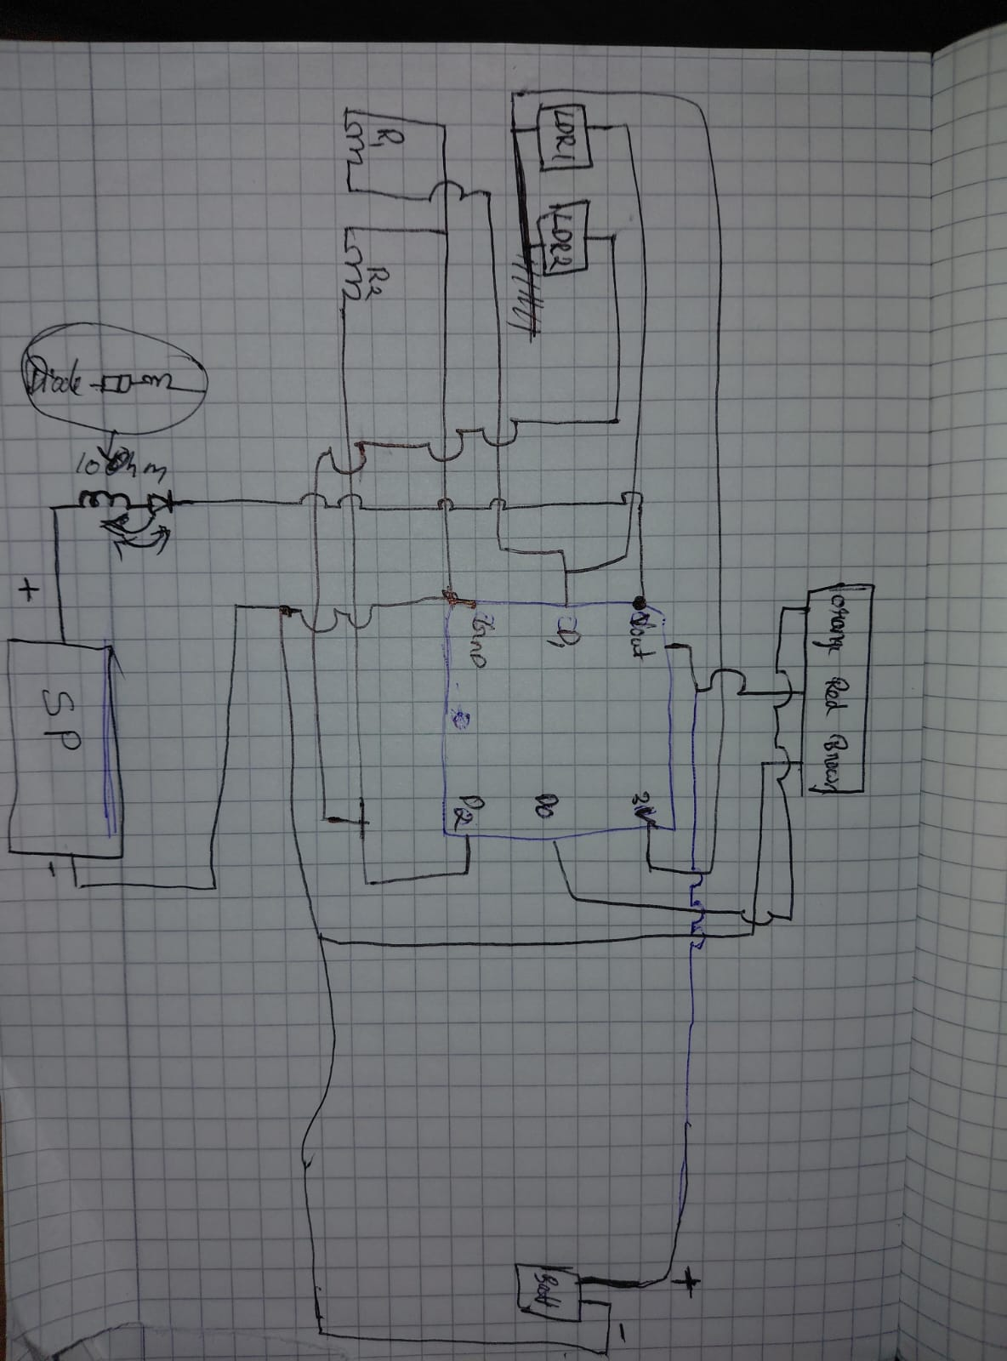
6. CIRCUIT CONNECTION

LDR Connections
LDR 1
* One side → 3V
* Other side → D1
* 10k resistor from D1 → GND
LDR 2
* One side → 3V
* Other side → D2
* 10k resistor from D2 → GND

BATTERY CONFIGURATION
Two 3.7V lithium batteries are connected in parallel connection.
Parallel Connection Features
* Voltage remains same:

V_{total}=V₁=V₂=3.7V
* Capacity increases:
Capacity_{total}=C₁+C₂

Example:

* 2 × 2000mAh batteries in parallel
* Total = 4000mAh

DIODE FUNCTION
The diode is used for:
1. Reverse polarity protection
2. Preventing reverse current flow
3. Protecting Gemma M0 and battery circuit

7. EQUATIONS USED
Voltage Divider Equation
V_{out}=V_{in}*R₂/(R₁+R₂)
This equation is used for the LDR voltage divider circuit.
PWM Frequency
f=50\ Hz
The servo motor operates at 50 Hz PWM frequency.
Pulse Width Range
1ms ≤ Pulse Width ≤ 2 ms
Different pulse widths control different servo angles.
Sensor Difference Equation
Difference=LDR₁-LDR₂
Used to determine the brighter direction.

8. ALGORITHM

1. Start system
2. Initialize sensors and servo motor
3. Read LDR1 value
4. Read LDR2 value
5. Compare sensor values
6. Rotate servo toward brighter side
7. Repeat continuously

Programming code
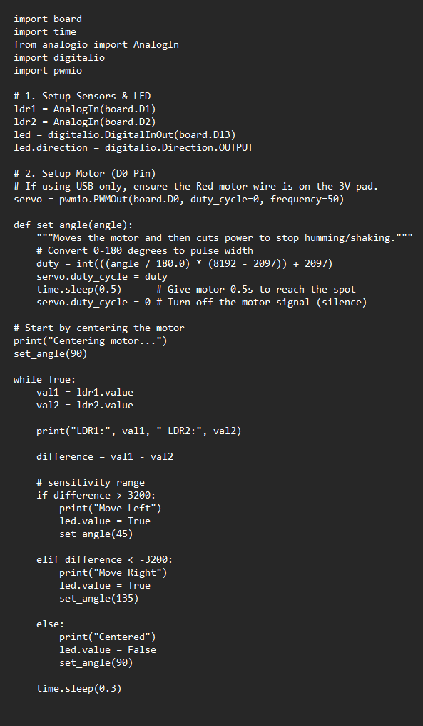
10. ADVANTAGES

1. Automatic operation
2. Improves efficiency
3. Low cost
4. Simple design
5. Easy to build
6. Educational project
7. Low power consumption

11. LIMITATIONS

1. Limited servo rotation range
2. Accuracy depends on light conditions
3. LDRs may be affected by shadows
4. Requires battery power

12. APPLICATIONS

1. Solar panel tracking
2. Smart street lights
3. Light-following robots
4. Renewable energy systems
5. Embedded systems learning
6. Educational automation projects

13. FUTURE IMPROVEMENTS

1. Dual-axis tracking system
2. Wireless monitoring
3. IoT integration
4. Rechargeable solar battery system
5. More accurate light sensors
6. Automatic brightness control

14. RESULT

The project successfully tracked the direction of the brightest light source using LDR sensors and rotated the SG90 servo motor accordingly. The Gemma M0 effectively controlled the entire system using CircuitPython programming.

15. CONCLUSION

The Solar Tracking Mini Light System demonstrates a practical implementation of automation and embedded systems using simple electronic components. The project successfully integrates LDR sensors, PWM servo control, and the Gemma M0 microcontroller to create an automatic light tracking mechanism.

This project improves understanding of:

* Sensor interfacing
* PWM control
* Embedded programming
* Automation systems
* Renewable energy applications

The system can be expanded into larger solar tracking systems for improved solar energy efficiency.

16. REFERENCES

1. Adafruit Gemma M0 Documentation
2. CircuitPython Documentation
3. SG90 Servo Motor Datasheet
4. Basic Electronics Notes
5. Embedded Systems Laboratory Manual

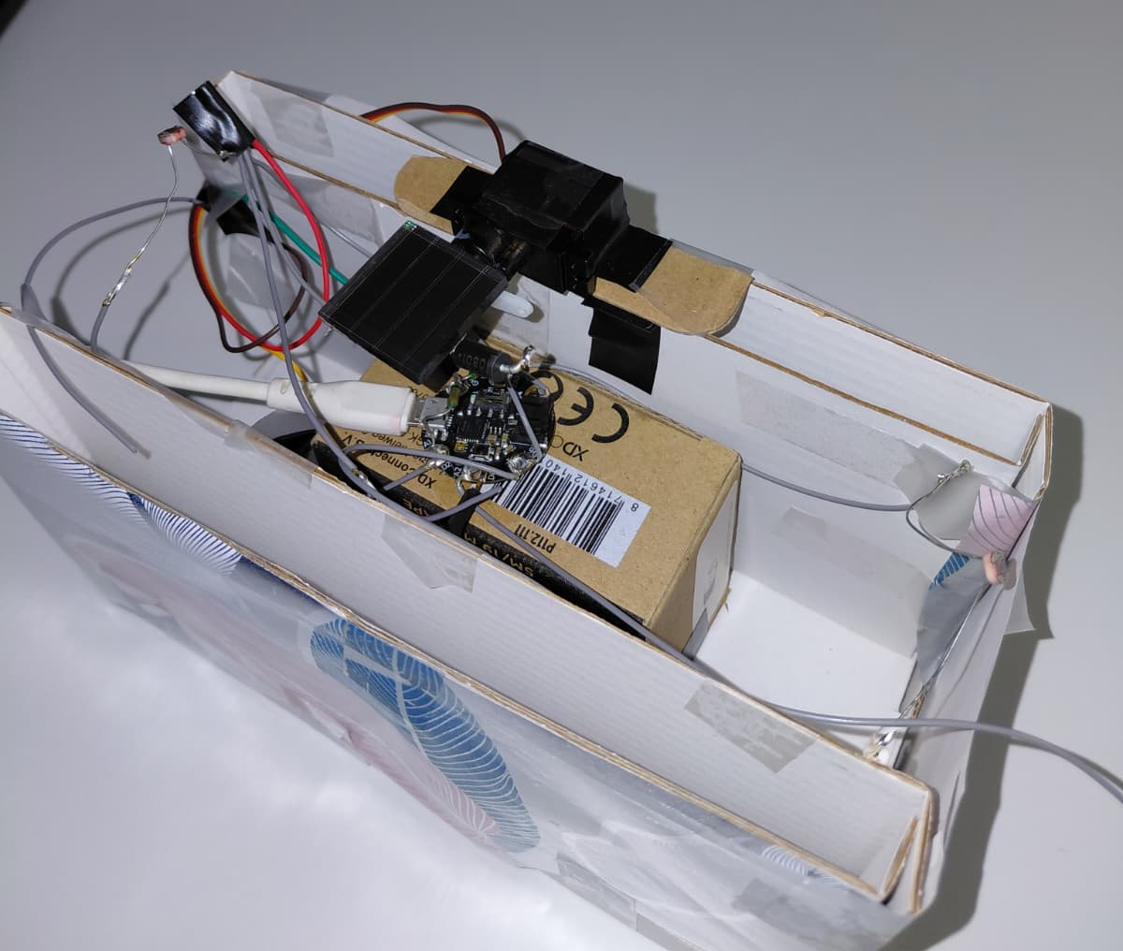
Photo and video

